Field Methods for Estimating the Organic Content in the Soil

Compiled by: Peter C. Fletcher, Jim Turenne, and Dr. Mark Stolt
If you are comfortable with it, I would like to list your names.

Being able to estimate the degree of decomposition (i.e., fibric, hemic, and sapric) and approximate the organic matter content (i.e., organic soil material, mineral soil material, and mucky mineral) of a soil using field tests is an essential skill for all wetland scientists.

Degree of Decomposition of Organic Matter
Depending upon the degree of decomposition, soil organic matter is classified into four categories: litter, fibric, hemic, and sapric. The degree of decomposition of organic matter is determined by the fiber content after rubbing. Live roots do not count as soil organic matter and are not considered when determining fiber content. Fibers are pieces of plant tissue in organic soil material that are 0.15 mm to 200 mm and show evidence of cellular structure.
Organic litter is recently fallen leaves and/or needles with no observable evidence of decomposition. Litter layers are most common in woodland areas and occur as a surface layer of loose, fluffy leaves, and/or needles that can be easily brushed aside with one’s hand or blown from one area to another by a strong wind. Typically within a year of being deposited on the ground surface and following repeated episodes of wetting and drying, plus snow cover; organic litter is transformed into an organic horizon (i.e., Oi) consisting of matted and slightly decomposed leaves, needles, and twigs.
For soils with surface organic layers, depth measurements for soil profile descriptions start below the litter layer and at the top of the organic layer that has observable evidence of decomposition (i.e., Oi, Oe, or Oa horizons). The thickness of the litter layer is documented by measuring and then recording the thickness as the number of inches to zero (e.g., Litter, +3 inches to 0). If there are no surface organic horizons, depth measurements are recorded from the top of the mineral soil material.
Soil organic matter with observable evidence of decomposition is classified into 3 different degrees of decomposition: fibric, hemic, or sapric.
Fibric material is slightly decomposed organic material with a rubbed fiber content of 40 percent or more (by volume). Typically the original source of the organic matter can be identified (e.g., red maple). Fibric material associated with wetness is referred to as peat.
Hemic material is organic material of intermediate decomposition with a rubbed fiber content of 17 to 40 percent (by volume). It often has the look and feel of mature compost. Hemic material associated with wetness is referred to as mucky peat.
Sapric material is the most highly decomposed of organic materials and has rubbed fiber content of less than 17 percent (by volume). It most often has a black or a very dark reddish black color with a massive appearance. Sapric material associated with wetness is referred to as muck.
Peat, Mucky Peat, and Muck
These are terms used to describe fibric, hemic, and sapric material associated with wetness. In these situations, the organic material either formed or was deposited in areas subject to flooding, ponding, and/or soil saturation. Peat, mucky peat, and muck are terms used only when describing wetland (hydric) soils. Not all wetland soil organic horizons are designated peat, mucky peat, and/or muck; and some are comprised of fibric, hemic, and/or sapric materials.
Key factors to consider when determining if a soil sample is peat, mucky peat, or muck are landscape position and presence of indicators of wetland hydrology. Soils with organic horizons comprised of peat, mucky peat, and muck are almost always found within depressions, swales, at the base of long slopes (foot and toeslopes), or in low areas adjacent to water bodies. They typically have indicators of wetland hydrology (e.g., water-stained leaves).
Peat: Fibric organic soil material. The plant forms can be identified in virtually all of the organic material. Bulk density is normally less than 0.1. Peat has three-fourths or more fibers after rubbing, or it has two-fifths or more fibers after rubbing and has sodium pyrophosphate solution extract color of 7/1, 7/2, 8/2, or 8/3.
Mucky peat: Hemic organic material, which is characterized by decomposition that is intermediate between that of fibric material and that of sapric material. Bulk density is normally between 0.1 and 0.2 g/cm3. Mucky peat does not meet the fiber content (after rubbing) or sodium pyrophosphate solution extract color requirements for either fibric or sapric soil material.
Muck: Sapric organic soil material in which virtually all of the organic material is so decomposed that identification of plant forms is not possible. Bulk density is normally 0.2 or more. Muck has less than one-sixth fibers after rubbing, and its sodium pyrophosphate solution extract color has lower value and chroma than 5/1, 6/2, and 7/3.
Note: Need to add statement about sodium pyrophosphate test.
Italicized text is taken directly from the Field Indicators of Hydric Soils in the United States, A Guide for Indentifying and Delineating Hydric Soils, Version 7.0, 2010.

Organic Soil Material, Mineral Soil Material,
and Mucky Mineral Soil
Soil material is divided into 3 categories depending upon the organic matter content within the soil: organic soil material, mineral soil material, and mucky mineral soil.
The criteria for organic soil material is defined differently depending on the landscape position (wetland vs. upland) where it has accumulated. Organic soil material that is saturated with water for long periods or artificially drained and, excluding live roots, has 18 percent or more organic carbon with 60 percent or more clay or 12 percent or more organic carbon with 0 percent clay. Soils with an intermediate amount of clay have an intermediate amount of organic carbon. If the soil is never saturated for more than a few days, organic soil material contains 20 percent or more organic carbon. Organic soil material includes muck, mucky peat, and peat.
Mineral soil material has a higher mineral content and less organic matter than organic soil material. In an upland setting mineral soils have less than 20 percent organic carbon. Wetland mineral soils have less than 12 to 18 percent organic carbon depending upon the clay content. As the clay content increases, the percentage of mineral soil material needed for the sample to qualify as organic soil material decreases.
A mucky mineral soil is a mineral soil material that has an unusually high amount of sapric organic matter. Mucky modified mineral soil material that has 0 percent clay has between 5 and 12 percent organic carbon. Mucky modified mineral soil material that has 60 percent clay has between 12 and 18 percent organic carbon. Soils with an intermediate amount of clay have intermediate amounts of organic carbon. Where the organic component is peat (fibric material) or mucky peat (hemic material), mucky mineral soil material does not occur. In New England, soils with a mucky mineral surface layer (i.e., A horizon) are almost always associated with wetland soils that have a seasonal high water table at or near the soil surface for significant periods of time.
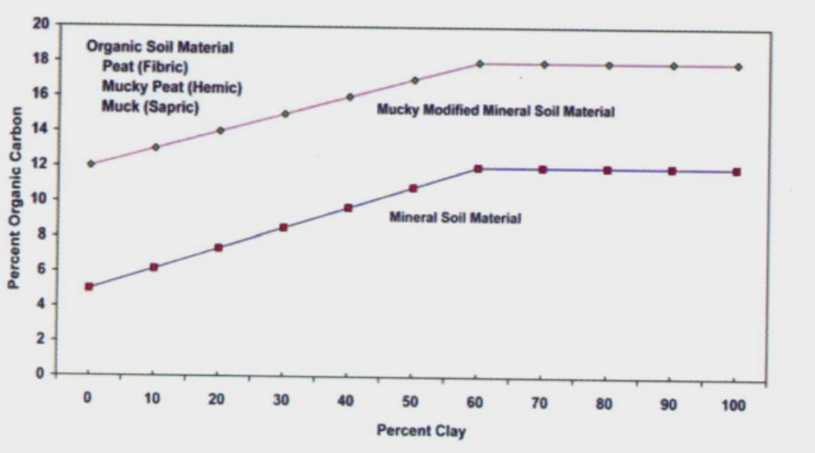
Percentage organic carbon required for organic soil material, mucky modified mineral soil material, and mineral soil material as it is related to content of clay (Field Indicators of Hydric Soils in the United States, A Guide for Identifying and Delineating Hydric Soils, Version 7.0, 2010).
The terms organic carbon (OC) and organic matter (OM) are often used when describing the criteria for an organic horizon. It is important to understand that these two terms are not interchangeable and have different meanings. Organic matter includes all forms of organic material (e.g., undecomposed and decomposed) where as organic carbon is restricted to the decayed plant and animal residues within the soil. A common conversion of OC to OM is to multiply the % OC by 1.724 to get the estimated % OM. For instance, 12% OC = 20% OM.

Field Tests for Organic Matter Determinations

Litter, Fibric, Hemic, and Sapric
Rubbed Fiber Content: Depending upon the degree of decomposition, soil organic matter is classified into four categories (litter, fibric, hemic, and sapric). The degree of decomposition of organic materials is determined by the fiber content after rubbing. The rubbed fiber content is estimated in the field by first taking a moist sample (about the size of a marshmallow) and removing the live roots. Live roots do not count as soil organic matter and are not considered when determining the fiber content. The sample is then rubbed between the thumb and fingers about 10 times using firm pressure. The rubbing shreds and breaks up any decomposed organic matter that is still intact. After rubbing, the sample is compressed into a round mass and then pulled apart into two halves. The percent fiber content is estimated by examining the broken face using a hand lens (10 power or more).
- Organic litter is recently fallen leaves and/or needles with no observable evidence of decomposition. Litter layers are most common in woodland areas and occur as a surface layer of loose, fluffy leaves and/or needles that can be easily brushed aside with one’s hand or blown from one area to another by a strong wind.
- Fibric material is slightly decomposed organic material. Most often the original source of the organic matter (e.g., red maple) can be identified. Fibric material has a rubbed fiber content of 40 percent or more (by volume).
- Hemic material is partially decomposed (intermediate decomposition) organic material. It often has the look and soft fluffy feel of mature compost. Hemic material has a rubbed fiber content of 17 to 40 percent (by volume).
- Sapric material is highly decomposed organic material. It most often has a black or a very dark reddish black color. When rubbed between one’s fingers, it has a slippery greasy feel. Sapric material has rubbed fiber content of less than 17 percent (by volume).

Peat, Mucky Peat, and Muck
Peat, mucky peat, and muck are terms used to describe fibric, hemic, and sapric materials associated with wetness. These terms should only be considered in areas where there is a high probability of soil saturation, flooding, and/or ponding. Key factors to consider when making this determination are landscape position and presence of indicators of wetland hydrology. Soils with organic horizons comprised of peat, mucky peat, and muck are almost always found within depressions, swales, at the base of long slopes (footslope and toeslope), or in low areas adjacent to water bodies. Organic surface horizons (Oi, Oe, and/or Oa horizons) associated with Histosols, histic epipedons, and soils that are gleyed in the upper part of the subsoil are almost always peat, mucky peat, and/or muck. In addition, these areas often have indicators of wetland hydrology (e.g., water-stained leaves). Not all wetland soil organic horizons are designated peat, mucky peat, and/or muck; and some are comprised of fibric, hemic, and/or sapric materials.
- Peat is fibric material associated with wetness. Water-stained leaves are a strong indicator of peat. Peat, as used in soil science, should not be confused with the same term used by landscapers that commonly refers to peat moss.
- Mucky peat is hemic material associated with wetness. It often has the look and soft feel of mature compost.
- Muck is sapric material associated with wetness. When air-dried, muck is light in weight and often remains as a mass that is moderately hard or hard to the touch.

Nature of Material Extruded on Squeezing
This is another test for determining the degree of decomposition of organic matter that is a visual examination of the color of the water that is expelled and the soil material remaining in the hand after a saturated sample is squeezed. For this test, an undisturbed saturated clod of soil, about the size of a lemon, is removed from the side of the pit. If the soil is unsaturated, the face of the pit should be moistened with a spray bottle before the clod is removed. Von Post scale – correct?
- Fibric/peat: When a saturated sample is squeezed the liquid expelled ranges from clear to brown and no organic solids ooze out from between the fingers.
- Hemic/mucky peat: When a saturated sample is squeezed, the liquid expelled ranges from dark brown to nearly black turbid) and up to a third of the sample oozes out between the fingers.
- Sapric/muck: When a saturated sample is squeezed, the liquid expelled is very dark to black (turbid) and greater than a third of the sample oozes out between the fingers.

Organic Soil Material, Mineral Soil Material,
Mucky Mineral Soil
Soil Color: Organic matter is the strongest coloring agent in New England soils and as little as 3 to 5 percent organic matter can impart a dark brown to black color in the soil. A common mistake in the field is assuming that a very dark soil color by itself is a reliable indicator for differentiating organic soil material from mineral soil material. A dark soil color may not be a reliable when working within areas with dark mineralogy.
- Organic soil material almost always has a moist color with values of 2.5 or less and chromas of 2 or less, and is a reliable indicator of the presence of organic matter in the soil. However, a dark color alone should never be used to determine whether or not a soil sample is organic soil material and additional field tests are needed. Exceptions are soils formed within tidal marshes which often have higher values, and mineral soils with dark mineralogy.
Un-rubbed Fiber Content: For this field test, the fiber content is determined by a visual estimate of the amount of fibers within a soil.
- Soil material (fibric and hemic) that has a high un-fiber content (greater than 1/3) is a strong indicator of organic soil material. Live roots do not count as soil organic matter and are not considered when determining fiber content.
Strength of Soil: For this test remove a clod of soil, about the size of a egg, from the side of the pit. The sample should be very moist but not saturated. If dripping wet, wrap the sample in a paper towel to remove excess water. When conducting this test, the soil sample should be squeezed but not repeatedly worked within one’s hand.
- When squeezed in one’s hand, the soil oozes out between the fingers, similar to the feel of mashed potatoes, this is a strong indicator of organic soil material (sapric and/or muck).
- Another form of the strength test is to clean the face of a test pit and probe the different horizons using one’s index finger. The finger will easily penetrate an organic horizon but cannot be pushed into a mineral horizon.
- Mucky mineral soils may have slight tendency to ooze between one’s fingers.
- Mineral soil material forms a solid mass and no soil material oozes between the fingers.
Air dry weight and color: Soil organic matter often acts as a sponge within the soil and absorbs and holds water. When air-dried, soil organic matter is significantly lighter in weight. When dried, well decomposed organic matter (sapric) will often shrink in size.
- When air-dried, organic soil material has a light weight and retains most of its dark color. This is a strong indicator of organic soil material.
- When air-dried, mucky mineral soil material retains much of its weight and some of its dark color (dry colors with values of 4 or less and chromas of 2 or less). This is an indicator of a mucky mineral soil material.
- When air-dried, mineral soil material retains much of its weight and dries a light color (dry colors with values of 5 or higher and chromas of 3 or more). This is a strong indicator of mineral soil material.
Greasy Feel: For this test, rub a moist soil sample between one’s thumb and index finger for approximately 5 or more times. Soils with a high silt and/or clay content also have a greasy feel but are most often slightly to very plastic.
- If after 5 rubs the sample has a greasy, slippery feel with no grittiness or plasticity, this is an indicator of organic soil material. This test should only be used in combination with other tests for organic soil material.

Mucky Modified Mineral Soil Material
Mucky Mineral Soil: Mucky modified mineral soil material that has 0 percent clay has between 5 to 12 percent organic carbon. Mucky modified mineral soil material that has 60 percent clay has between 12 and 18 percent organic carbon. Soils with an intermediate amount of clay have intermediate amounts of organic carbon. Where the organic component is peat or mucky peat, mucky mineral soil material does not occur.
Soil Color: Mucky mineral soils have colors with values of 2.5 or less and chromas of less than 2. An exception is soils formed within tidal marshes which often have higher values.
Feel Test: Gently rub a wet soil sample between index finger and thumb. If upon the first or second rub the material feels gritty, it is mineral soil material. If after the second rub the material feels greasy, it is either mucky mineral or organic soil material. Gently rub the material two or three more times. If after these additional rubs it feels gritty or plastic, it is mucky mineral soil material; if it still feels greasy, it is organic soil material. This method may be inconclusive with loamy or clayey textured mineral soils.
A good field practice when doing this test is to first texture the mineral soil horizon (E or B horizon, or C layer) directly underling the horizon in question. The assumption when doing this is that both horizons have the same mineral texture except that the underlying horizon does not have the organic matter. By doing this first, a person can better gauge the grittiness of the mineral soil material and the greasiness of the organic matter. Caution, when doing this test you are assuming that the mineral texture is the same in both horizons, which is often the case.
Air-dry Color: Rub a moist sample within palm to breakup and mix the soil sample. Then, using thumb, smear a sample onto a white heavy weight paper. The sample should be thick enough to mask the white of the underlying paper, about 2 mm thick. Place in a sunny area and dry.
- Mucky Mineral Soil: When dry, a mucky mineral soil dries a dark shade of gray with values of 4 or less and chromas of less than 2. When held up to the light, the reflection off the sand and silt particles can be seen. Particles of mica will also do this and are an indicator of mineral soil particles.
- Mineral Soil Material: When dry, mineral soil material dries a surprisingly light shade of gray with values of 5 or more.
- Organic Soil Material: When dry organic soil material retains most of its color when dry and lacks the glisteny reflection of sand and silt particles.
Important: When using the above chart, it is essential to use a combination of two or more of the above tests to make a determination. It is also important recognize that in some particularly difficult situations there are diverse opinions by professionals that can often only be resolved by laboratory analysis.

